* Prereqs will be checked daily by the single head assigned operator, or by operators once they clear their schedule for the day.

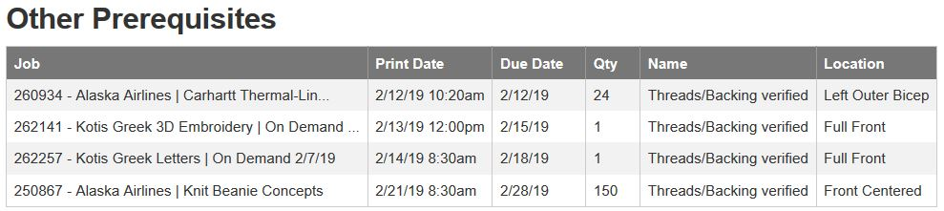

Embroidery Prerequirements are found under the category “**Threads/Backing verified**”

This is asking if we have the needed backing, bobbins and thread in stock that matches the PMS call out.

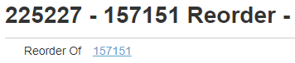

**1A)** If this is a reorder:

look at previous orders “Ink Recipe” section and copy thread callouts into the new orders “Ink Recipe”.

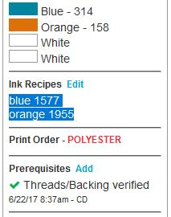

*If this is a reorder from another embroidery shop, we should check to make sure there are no notes regarding thread used at other shop and then **skip to 1B**.

To check out previous jobs for brands refer to the Customers Thread callout doc. We are trying to switch everything to [Appsheets](https://www.appsheet.com/start/b0be39a0-5dfd-4f5a-bc9a-b10a198cee1a#appName=ProductionControlSamples-464556&page=gallery&sort=%5B%5D&table=PMS+Match&view=PMS). This doc will be updated at that time once it’s in place.*

**1B)** If this is not a reorder, You will need to select the thread for this order. The Madeira Website offers a [PMS matching service here](http://www.madeiramart.com/pantone-color-match).

**Type in the PMS color you are trying to match:** 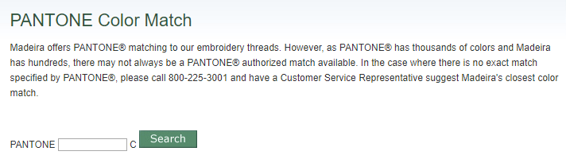

**And it will recommend a color**

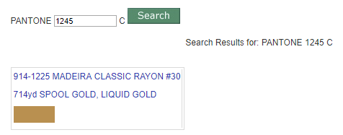

**or tell you there is no perfect match.**

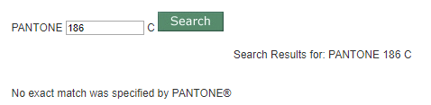

Use the PMS swatch book and Madeira Poly-Neon swatch book to choose the best thread color.

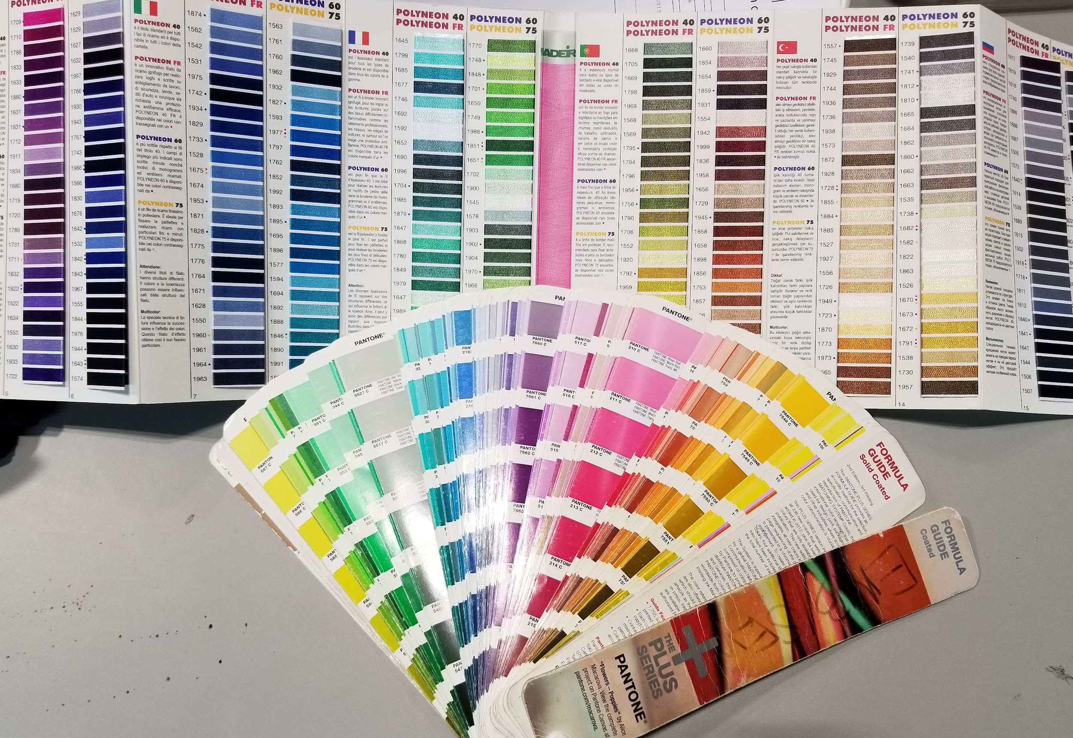

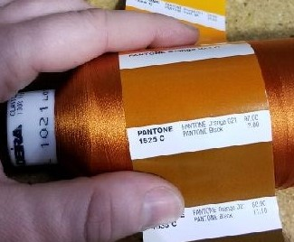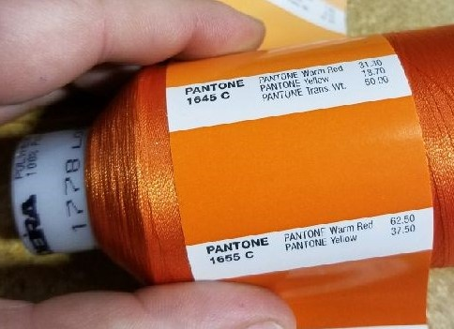

Thread is stored on wall by number if you want to consult and compare the spool to the PMS swatch. It’s handy to show pictures of this in the photoproof too to reassure sales they match.

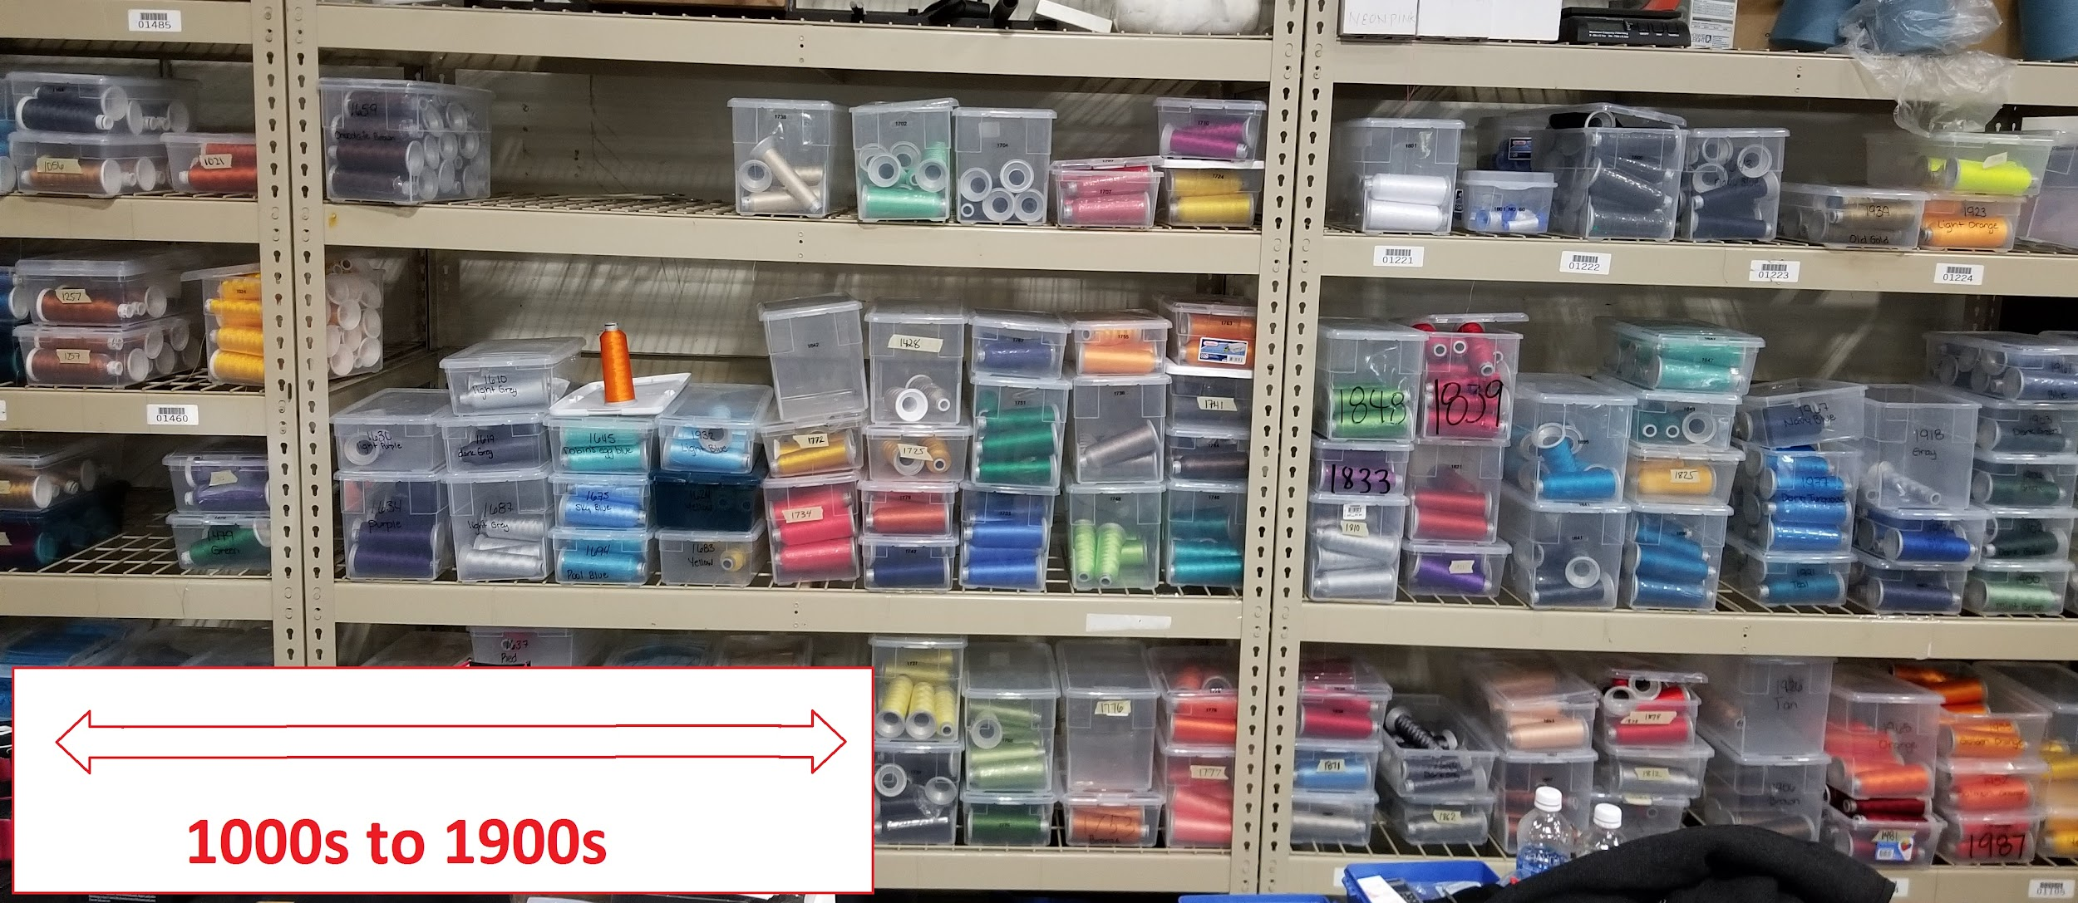

*If we do not have 8 spools in stock, write the thread color # needed on white board. New supplies are bought on Thursday, if something is needed sooner, alert supervisor.

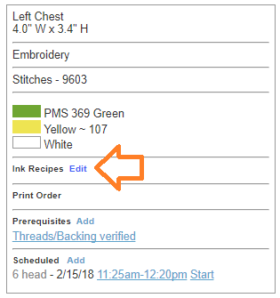

**2)** Once you have the thread color picked out for the order, Click on the “edit” button of the Ink Recipes section of the PO.

Adding this data is important so when a reorder is put in, we can use the same thread every time for a perfect match.

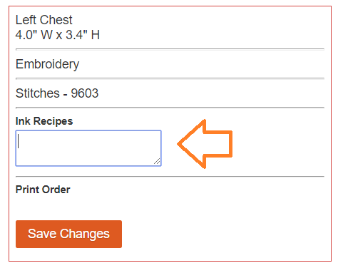

**3)** You can type in all the thread colors you have selected into this box.

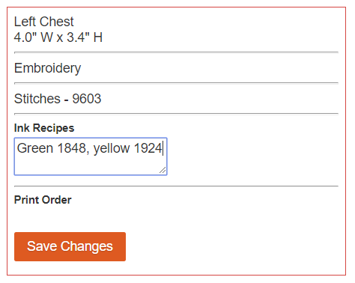

**4)** Its helpful to say what color it is before the thread number so in the future we can find the thread faster.

Hit “Save Changes” to save the data you have added.

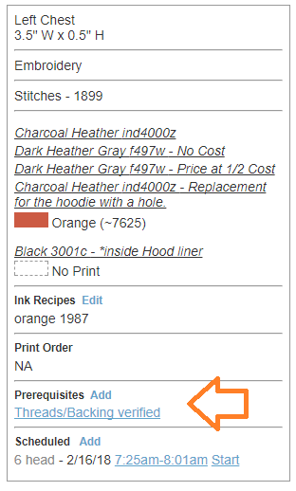

**5)** Next click on “Threads/Backing verified” to sign off that you have added the thread recipe to the “Ink Recipe section.

This can be checked off without filling in for thread colors White 1601 and Black 1600 since those never change.

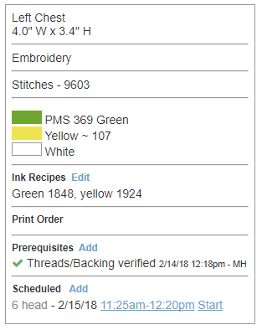

This is a completed Prereq. The thread color is added in to the “Ink Recipe” section and the “Threads/Backing verified” has been checked off! Great Job!